# Registering in the app

On first loading the app it is best to set your location.

1. Click on ‘Set Location’.
2. Enter your personal details (Name, Phone (optional), Email (Optional) and first line of address. (e.g. ‘22 Grosvenor Place’)
3. Click ‘Next’ – this should then search for your address. When the list of addresses appears select the right one.
4. It will take around 5 seconds to load your personalised data.

# Navigating within the app

Navigation through the app is primary done by selecting the ‘hamburger’ menu at the top left hand corner.

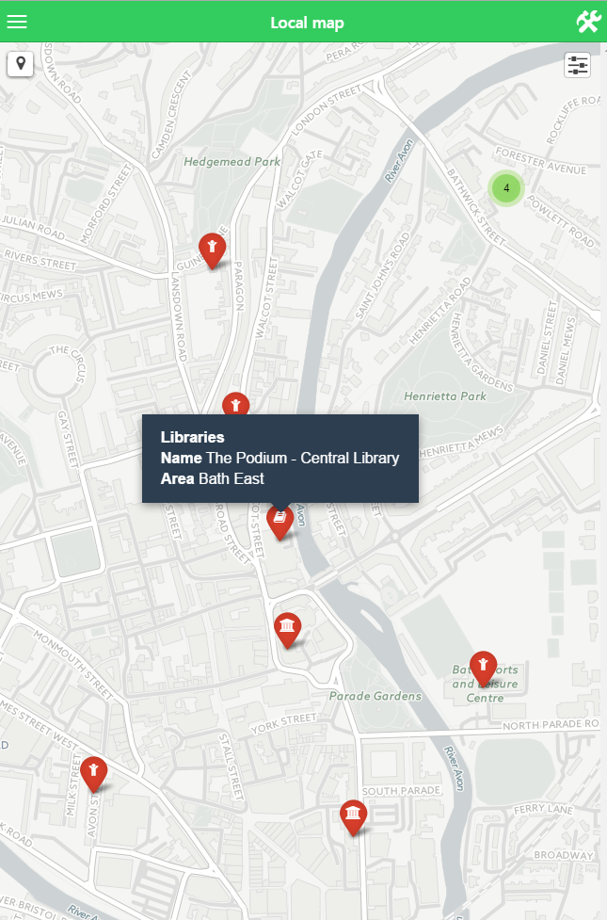

Alternatively the menu drawer can be accessed by sliding it from the left side of the screen with your finger.

# Action buttons

Generally within the app there are ‘action buttons’ which have an icon and associated text. For example, on the ‘My Council’ page there should be contact actions listed underneath your councillors (where the relevant data is available).

# Live map

On the menu the live map appears as ‘Local map’, and is the last item listed. The map should automatically detect your location – though you will initially be prompted to allow this.

Items of interest are added by selecting the layer control that appears over the map in the top right hand corner.

